Cyclistic Bike-Share Analysis Case Study
  - Google Data Analytics Professional Certificate — Capstone Project
Author:
Nikolaou Evangelos

Date
11/19/2025

Executive Summary
Cyclistic, a bike-share program based in Chicago, is focused on increasing its annual membership base. Annual members are highly valuable to the business, as they contribute to more stable and predictable long-term revenue compared to casual riders.
To support Cyclistic’s strategic growth goals, a detailed analysis was conducted to investigate the differences in usage patterns between annual members and casual riders. The study utilized 12 months of historical trip data. This dataset was meticulously cleaned and transformed, and then analyzed using Google BigQuery, which enabled the efficient handling of millions of records and ensured high data integrity.

Key Findings
The analysis identified distinct behavioral differences between the two rider groups:
- Ride Frequency and Timing: Annual members tend to ride significantly more often, with a pattern that aligns closely with weekday commuting. In contrast, casual riders are more active on weekends, and their trips are generally longer, suggesting their primary motivation is leisure rather than routine travel.
- Bike Type Preferences: Casual riders show a greater affinity for electric bikes, whereas annual members consistently choose classic bikes, likely because these suit their daily commuting needs.
- Visualization Insights: Visual data representations highlight that members dominate ridership volume during weekdays, while casual riders have the highest usage on Saturdays and Sundays. Furthermore, the average ride duration for casual riders is nearly three times longer than that of annual members. Seasonal patterns show that casual rider activity peaks in the summer months.

ASK

Implications for Marketing Strategy
These insights provide a strong foundation for developing targeted, data-driven marketing strategies. By understanding the unique motivations and habits of each group, Cyclistic can design promotions, commuter-focused messaging, and pricing incentives that appeal specifically to casual riders, encouraging them to become annual members. These recommendations will be further detailed in the ACT phase, with the goal of maximizing Cyclistic’s membership growth.
Business Task
Cyclistic seeks to gain a deeper understanding of how annual members and casual riders differ in their use of the bike-share system. By pinpointing the behavioral distinctions between these two groups, the marketing team’s objective is to create targeted strategies that will convert casual riders into annual members. Annual memberships offer greater profitability and ensure more stable long-term revenue for the business.
To accomplish this goal, the business task focuses on analyzing 12 months of Cyclistic trip data. The analysis will explore actionable usage patterns such as ride duration, ride frequency, preferred days of the week, seasonal trends, and the types of bikes most frequently used. With these insights, the marketing team will be equipped to design data-driven campaigns aimed at effectively encouraging casual riders to purchase annual memberships.

Stakeholders
- Lily Moreno – Director of Marketing and project sponsor
- Cyclistic Marketing Analytics Team – Responsible for utilizing the findings to guide marketing strategy
- Cyclistic Executive Team – Decision-makers who will review and approve proposed marketing initiatives
- Junior Data Analyst – Tasked with conducting the analysis and communicating key insights

PREPARE

Data Source Overview
This analysis is based on the public Divvy/Cyclistic bike-share dataset, which is provided by Motivate International Inc. The data is made available through the Divvy Trip Data Repository and contains actual operational trip records from Chicago’s bike-share system. While Cyclistic is a fictional entity created for this case study, the dataset itself is genuine and licensed for public analysis.

Data Location and Organization
The dataset was downloaded directly from the official Divvy public data portal: https://divvy-tripdata.s3.amazonaws.com/. For organizational purposes, all files were stored in a dedicated local project folder, with subfolders separating the original CSV files from processed versions.
The data is divided into 12 monthly CSV files, each containing between several hundred thousand to over half a million rows. Every file follows an identical schema, which includes the following key fields:
- ride_id
- rideable_type
- started_at
- ended_at
- start_station_name / end_station_name
- member_casual
Each row represents a single bike trip within the system. The consistent structure across files ensures that the data can be reliably merged and analyzed for trends throughout the entire year.

Credibility and ROCCC Assessment
- Reliable: The dataset is provided directly by Motivate International Inc.
- Original: It contains first-party trip data collected from the bike-share system.
- Comprehensive: All trips recorded during each month are included.
- Current: The data covers a full recent year and is updated monthly.
- Cited: The dataset is distributed under an open data license.

Licensing, Privacy, and Security
The dataset is accessible to the public and licensed for analytical and educational purposes. All personally identifiable information (PII) has been removed to safeguard privacy. Only ride-level operational data is included, with no demographic or payment information collected.

Data Integrity Verification
Prior to analysis, the dataset was examined using both Excel and BigQuery to check for:
- Missing values in critical fields
- Inconsistent timestamps
- Negative or unrealistic trip durations
- Duplicate ride IDs
- Column name and schema consistency across all months
These verification steps confirmed that the dataset was suitable for data cleaning and further analysis.

Limitations
- Some rows are missing station names or IDs
- Occasional negative or invalid timestamps exist
- Demographic data is not available
- The large file size necessitates processing in BigQuery rather than Excel
Despite these limitations, the dataset is sufficiently complete and appropriate for analyzing and identifying usage differences between annual members and casual riders.

PROCESS

Tools Used
Due to the substantial size of the Cyclistic dataset, which consists of millions of rows and surpasses the capacity of tools like Excel and Google Sheets, Google Big Query was selected as the primary platform for data cleaning and transformation. Big Query offers robust, scalable SQL processing capabilities, making it ideal for managing large datasets. Additionally, it integrates seamlessly with Google Cloud Storage, where the raw CSV files were initially uploaded. In the preliminary stage, Excel was used solely for the initial inspection of data formatting and to ensure structural consistency across files.

Data Cleaning and Transformation Steps
After uploading the twelve-monthly CSV files to Google Cloud Storage, each file was imported into a dedicated BigQuery dataset labeled Cyclistic_Raw. The following steps were executed to clean and prepare the data for analysis:
- Combined all monthly tables into one table:
All twelve-monthly tables were merged using the UNION ALL operation, resulting in a complete, unified dataset that spans the entire year. This consolidation facilitated comprehensive analysis by eliminating the need to work with separate monthly files.
- Removed rows with missing critical data:
Initial validation queries revealed that certain records were missing essential fields, such as start_station_name, end_station_name. These incomplete records lacked the necessary information for meaningful analysis and were therefore excluded using BigQuery SQL filters.
- Calculated ride duration:
A new field, ride_length_min, was created to represent the duration of each trip in minutes:
This metric is crucial for comparing trip durations between members and casual riders.
- Removed invalid or extreme ride lengths:
Data validation identified records with negative ride durations or durations exceeding 24 hours, both of which are indicative of data errors or improperly logged trips. These records were removed using SQL conditions to ensure the dataset's accuracy.
- Added day_of_week field:
To assist in identifying ride patterns by day, a day_of_week field was extracted using the following method:
Here, 1 represents Sunday and 7 represents Saturday. This field enables analysis of usage trends across weekdays and weekends.
- Removed duplicate ride IDs:
A window function with ROW_NUMBER() was applied to detect and retain only one entry per ride_id. This step ensured that no ride was counted more than once in subsequent analyses.

Data Integrity Verification
To ensure the dataset was thoroughly cleaned and ready for analysis, several validation queries were performed:
- Counted total rows after cleaning
- Verified there were no NULL values in critical fields
- Checked the distribution of ride_length_min
- Confirmed only valid user types (member, casual) remained
- Ensured day_of_week values ranged from 1 to 7
- Confirmed the absence of negative or unrealistic ride durations
The final cleaned table, all_trips_final, contains consistent, valid, and reliable records suitable for further analysis.

Result of the PROCESS Phase
Upon completion of the PROCESS phase, a fully cleaned and transformed BigQuery table was obtained, characterized by the following attributes:
- All twelve months combined into a single dataset
- No missing critical values
- Accurate calculation of ride durations
- Extracted day-of-week information
- No duplicate rides
- Consistent formatting across all fields
This comprehensive and reliable dataset is now prepared for the ANALYZE phase, where exploration of behavioral differences between annual members and casual riders will be undertaken.

ANALYZE

Summary of Analysis
During the ANALYZE phase, the cleaned Cyclistic dataset was aggregated and examined to identify differences in usage patterns between annual members and casual riders. The analysis led to several key findings that demonstrate distinct behaviors between these groups:
- Frequency of Rides: Annual members tend to ride more frequently, with a pronounced preference for weekdays. This pattern suggests that many members use Cyclistic bikes primarily for commuting purposes.
- Duration and Timing: Casual riders typically take longer rides, and their usage peaks during weekends. This indicates that casual riders are more likely to use the service for recreational and leisure activities rather than for daily commuting.
- Bike Type Preferences: Electric bikes are more popular among casual riders, while annual members predominantly use classic bikes. This difference may reflect the casual riders’ interest in trying newer bike technologies or seeking a more relaxed riding experience.
- Seasonal Trends: Casual riders exhibit strong seasonal patterns, with their ridership increasing significantly during warmer months. In contrast, annual members maintain consistent usage throughout the year, regardless of season.
These insights will help guide marketing strategies aimed at converting casual riders into annual members by targeting their riding motivations and habits.

SHARE

Communicating Insights to Stakeholders
The primary objective of the SHARE phase is to present the findings from the analysis in a clear and impactful manner for Cyclistic stakeholders. To achieve this, four visualizations were developed, each designed to emphasize distinct behavioral differences between annual members and casual riders. All visualizations were produced by summarizing data with SQL in BigQuery and creating charts in Google Sheets, ensuring that the results are both accessible and visually consistent.

Visualization 1: Total Rides by User Type
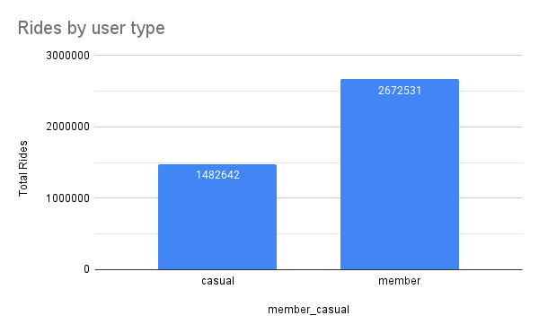

This visualization compares the total number of rides taken by annual members and casual riders. The results highlight that annual members completed substantially more rides than casual riders, underscoring their role as a consistent and reliable user segment for Cyclistic. The considerable gap in ride counts indicates that members contribute to steady recurring usage of the service.

Visualization 2: Average Ride Duration
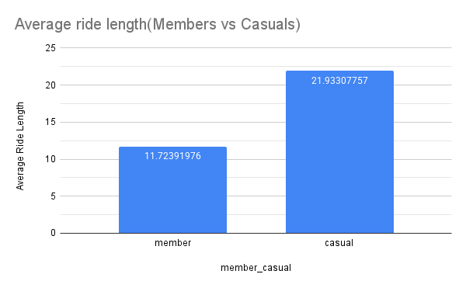
This chart illustrates the difference in average ride duration between the two user types. Casual riders tend to take significantly longer trips than annual members. This pattern suggests that casual riders are typically engaging in activities that are more leisurely or recreational, whereas members are likely to use the service for quicker, routine commutes.

Visualization 3: Rides by Day of Week
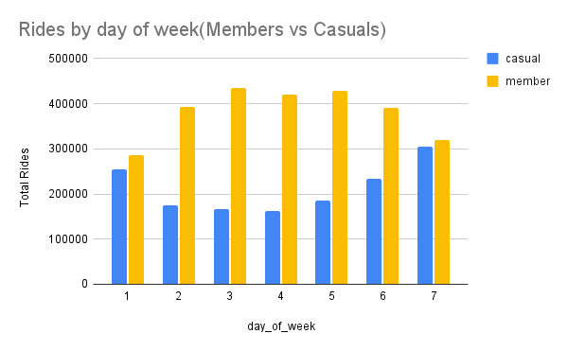
This grouped bar chart displays the distribution of rides across the days of the week for both user groups. Annual members ride most frequently during weekdays, with a noticeable peak from Tuesday to Thursday, reflecting a strong commuting pattern. In contrast, casual riders show a marked increase in rides on weekends, confirming a strong preference for recreational use. These trends reinforce that the two groups utilize Cyclistic bikes for very different purposes.

Visualization 4: Average Ride Length by Day of the Week
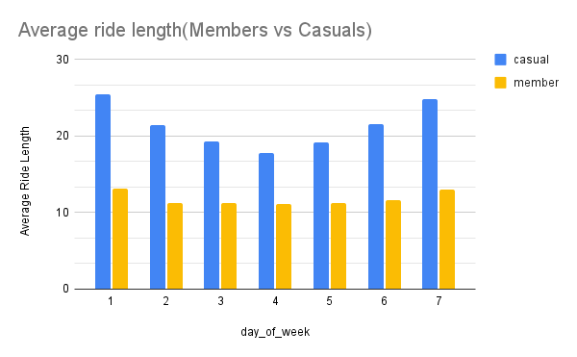
This visualization provides a detailed comparison of ride durations across the days of the week for both annual members and casual riders. The data reveal that casual riders consistently take longer rides than members every day, with their average ride duration peaking during weekends. This pattern strongly suggests that casual riders primarily use Cyclistic bikes for recreational and leisure activities, taking advantage of weekends for extended outings.
In contrast, annual members exhibit shorter and more stable ride durations throughout the week. Their consistent riding times reflect routine commuting habits, as members tend to use the service for regular, everyday travel rather than for leisure. The clear distinction in usage patterns between the two groups highlights the recreational focus of casual riders and the practical, routine orientation of annual members.

Visualization 5: Rideable Type Preference
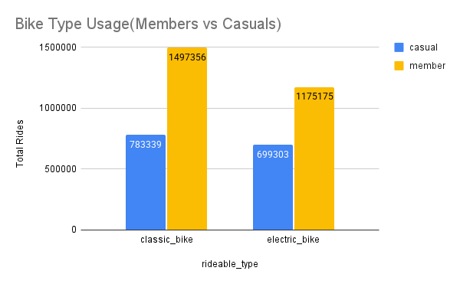
The visualization reveals the preferred bike types among users. Casual riders more often choose electric bikes, indicating a possible preference for comfort, novelty, or a willingness to pay a premium. In contrast, annual members demonstrate a strong preference for classic bikes, which may align with routine commuting needs and cost-consciousness.

Visualization 6:Monthly Ridership Trends: Seasonality
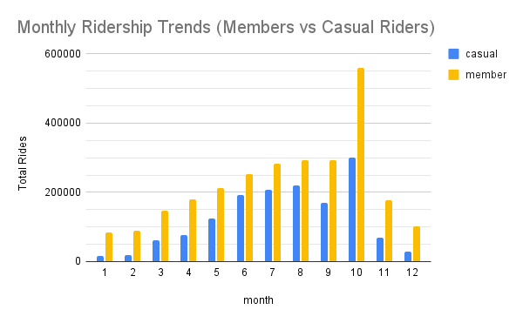
This visualization presents a comprehensive comparison of monthly ridership patterns between annual members and casual riders over the course of a full year. The data highlights a distinct seasonal trend among casual riders, whose ridership increases dramatically during the warmer months, particularly from June through September. During this period, casual usage reaches its peak in late summer, reflecting a preference for leisure activities that are strongly influenced by favorable weather conditions. Conversely, as the weather turns colder, the number of casual rides drops sharply, underscoring the weather-dependent nature of their usage.
In contrast, annual members demonstrate much more consistent ridership throughout the year. While there is a gradual increase in member ridership from spring through fall, the seasonal variation is significantly less pronounced compared to casual riders. Notably, even in the winter months, annual members maintain a higher level of usage, indicating that their reliance on Cyclistic bikes extends beyond seasonal recreation. This stability in ridership suggests that members primarily use the service for routine, year-round commuting rather than for leisure alone.

Key Findings
The analysis of Cyclistic user data reveals a distinct contrast in riding behaviors, preferences, and patterns between annual members and casual riders. These differences are summarized below:

1. Higher Frequency of Rides Among Members
Annual members consistently account for the majority of total trips throughout the year, with a particularly strong presence during weekdays. This pattern points to a reliance on Cyclistic bikes for regular transportation and commuting, highlighting that members use the service as an integral part of their daily routines.

2. Longer Ride Durations by Casual Riders
Casual riders take significantly longer rides than annual members, with average durations often nearly three times as long. This trend suggests that casual users are primarily engaging in unhurried, leisure-focused trips, taking advantage of the opportunity for recreation rather than routine travel.

3. Day-of-Week Usage Patterns Highlight Distinct Motivations
Annual members display peak riding activity between Tuesday and Thursday, aligning with traditional workweek commuting schedules. In contrast, casual riders show a pronounced surge in bike usage on Saturdays and Sundays, reinforcing the idea that their rides are mainly for recreational purposes.

4. Divergent Bike Type Preferences
The two user groups also differ in their choice of bike type. Casual riders tend to prefer electric bikes, which may reflect a desire for convenience, comfort, or novelty, and a lesser concern for per-ride costs. On the other hand, annual members primarily use classic bikes, likely due to predictable commuting needs and the appeal of lower, more consistent pricing.

5. Daily Ride Length Patterns Emphasize Weekend Leisure
Throughout the week, casual riders maintain longer ride durations than members, with the difference becoming especially pronounced on weekends. Members, however, show stable and shorter ride lengths from Monday to Friday, further supporting the notion of routine, practical transportation usage.

6. Seasonal Trends: Leisure vs. Consistent Commuting
Seasonal analysis reveals that casual ridership peaks dramatically during the warmer months from June through September and declines sharply in winter, indicating a strong sensitivity to weather and a preference for summer recreation. In contrast, annual members maintain relatively steady ridership throughout the year, demonstrating less influence from seasonal changes and reinforcing their use of Cyclistic bikes for year-round commuting.

These visualizations offer compelling evidence of the distinct behaviors exhibited by annual members and casual riders. The insights gained will play a crucial role in informing targeted marketing strategies in the ACT phase, aiming to better address the motivations and preferences of each user group.

ACT

Marketing Recommendations for Increasing Annual Memberships
An in-depth analysis of twelve months of Cyclistic trip data has revealed distinct behavioral patterns between annual members and casual riders. These patterns provide a foundation for developing targeted marketing strategies aimed at converting casual riders into annual members. The following recommendations are derived directly from the observed data trends.

1. Target Weekend and Leisure Riders with Membership Promotions
Casual riders tend to take longer trips and their usage peaks during weekends, indicating that their ride patterns are primarily leisure-oriented. To capitalize on this behavior, Cyclistic should focus marketing efforts on casual riders who are active on weekends. Key tactics include offering weekend-specific membership discounts, introducing "Frequent Rider" plans tailored for extended leisure trips, and sending push notifications or email offers to users after they complete multiple long-duration rides. By aligning these promotions with the established habits of casual riders, Cyclistic can more effectively communicate the value of an annual membership for frequent leisure use.

2. Promote Annual Membership as a Cost-Effective Option for Electric Bike Users
Data shows that casual riders are much more likely to use electric bikes compared to members. Since electric bike rides incur higher per-trip costs, they represent a significant revenue source as well as a strong incentive for conversion if presented properly. Cyclistic should emphasize the potential cost savings for frequent electric bike users by highlighting how much they might save with membership. Strategies may include offering membership add-ons or "Electric Bike Passes," and using in-app messaging to illustrate the savings a casual user could achieve as a member. This approach leverages the popularity and higher cost of electric bike usage to encourage casual riders to switch to an annual membership.

3. Emphasize Weekday Convenience and Reliability to Appeal to Potential Commuters
Annual members predominantly ride during weekdays, especially between Tuesday and Thursday, reflecting strong commuter usage. Cyclistic can target casual riders who occasionally ride on weekdays by positioning the membership as a convenient and reliable commuting solution that also offers cost savings. Recommended strategies include providing "Try a Month as a Member" commuter trial passes, running advertisements that emphasize the predictability and reliability of weekday travel with a membership, and collaborating with employers to offer subsidized memberships. These efforts are designed to convert casual riders who may already be using the service for weekday commutes into committed annual members.

Conclusion
Collectively, these recommendations are aligned with Cyclistic’s objective of boosting annual memberships by addressing the actual behaviors and motivations of casual riders. By tailoring membership benefits to appeal to weekend leisure usage, electric bike savings, and weekday commuting convenience, Cyclistic is well-positioned to convert more casual riders into loyal, long-term members.

Appendix A – SQL Used for Data Preparation and Cleaning
This appendix documents the main SQL queries used in Google BigQuery during the PROCESS phase of the Cyclistic case study.

A1. Combine Monthly Tables into a Single Raw Table
CREATE OR REPLACE TABLE
`numeric-dialect-471508-j5.Cyclistic_Raw.all_trips_raw` AS
SELECT * FROM `numeric-dialect-471508-j5.Cyclistic_Raw.2024_01`
UNION ALL SELECT * FROM `numeric-dialect-471508-j5.Cyclistic_Raw.2024_02`
UNION ALL SELECT * FROM `numeric-dialect-471508-j5.Cyclistic_Raw.2024_03`
UNION ALL SELECT * FROM `numeric-dialect-471508-j5.Cyclistic_Raw.2024_04`
UNION ALL SELECT * FROM `numeric-dialect-471508-j5.Cyclistic_Raw.2024_05`
UNION ALL SELECT * FROM `numeric-dialect-471508-j5.Cyclistic_Raw.2024_06`
UNION ALL SELECT * FROM `numeric-dialect-471508-j5.Cyclistic_Raw.2024_07`
UNION ALL SELECT * FROM `numeric-dialect-471508-j5.Cyclistic_Raw.2024_08`
UNION ALL SELECT * FROM `numeric-dialect-471508-j5.Cyclistic_Raw.2024_09`
UNION ALL SELECT * FROM `numeric-dialect-471508-j5.Cyclistic_Raw.2024_10`
UNION ALL SELECT * FROM `numeric-dialect-471508-j5.Cyclistic_Raw.2024_11`
UNION ALL SELECT * FROM `numeric-dialect-471508-j5.Cyclistic_Raw.2024_12`

A2. Check for Missing Values in Critical Columns
SELECT
COUNTIF(start_station_name IS NULL) AS missing_start_station_name,
COUNTIF(end_station_name IS NULL) AS missing_end_station_name,
COUNTIF(started_at IS NULL) AS missing_started_at,
COUNTIF(ended_at IS NULL) AS missing_ended_at,
COUNTIF(rideable_type IS NULL) AS missing_rideable_type,
COUNTIF(member_casual IS NULL) AS missing_member_casual
FROM `numeric-dialect-471508-j5.Cyclistic_Raw.all_trips_raw`

A3. Create Cleaned Table with New Fields
CREATE OR REPLACE TABLE
`numeric-dialect-471508-j5.Cyclistic_Raw.all_trips_cleaned_step1` AS
SELECT
*,
TIMESTAMP_DIFF(ended_at, started_at, MINUTE) AS ride_length_min,
EXTRACT(DAYOFWEEK FROM started_at) AS day_of_week
FROM `numeric-dialect-471508-j5.Cyclistic_Raw.all_trips_raw`
WHERE
start_station_name IS NOT NULL
AND end_station_name IS NOT NULL
AND started_at IS NOT NULL
AND ended_at IS NOT NULL
AND rideable_type IS NOT NULL
AND member_casual IS NOT NULL

A4. Filter Out Invalid Ride Durations
CREATE OR REPLACE TABLE
`numeric-dialect-471508-j5.Cyclistic_Raw.all_trips_cleaned_step2` AS
SELECT *
FROM `numeric-dialect-471508-j5.Cyclistic_Raw.all_trips_cleaned_step1`
WHERE
ride_length_min > 0 -- remove negative durations
AND ride_length_min < 1440 -- keep rides shorter than 24 hours

A5. Remove Duplicate Ride IDs
CREATE OR REPLACE TABLE
`numeric-dialect-471508-j5.Cyclistic_Raw.all_trips_final` AS
SELECT *
FROM (
SELECT
*,
ROW_NUMBER() OVER (
PARTITION BY ride_id
ORDER BY started_at DESC
) AS rn
FROM `numeric-dialect-471508-j5.Cyclistic_Raw.all_trips_cleaned_step2`
)
WHERE rn = 1

A6. Sanity Checks on Final Table
-- Total number of rows
SELECT COUNT(*) AS total_rows
FROM `numeric-dialect-471508-j5.Cyclistic_Raw.all_trips_final`

-- Distribution of ride length
SELECT
MIN(ride_length_min) AS min_ride_length,
AVG(ride_length_min) AS avg_ride_length,
MAX(ride_length_min) AS max_ride_length
FROM `numeric-dialect-471508-j5.Cyclistic_Raw.all_trips_final`

-- User types
SELECT member_casual, COUNT(*) AS rides
FROM `numeric-dialect-471508-j5.Cyclistic_Raw.all_trips_final`
GROUP BY member_casual

-- Days of week
SELECT day_of_week, COUNT(*) AS rides
FROM `numeric-dialect-471508-j5.Cyclistic_Raw.all_trips_final`
GROUP BY day_of_week
ORDER BY day_of_week

Appendix B – SQL Used for Data Analysis
This appendix contains the SQL queries used in the ANALYZE phase to summarize and explore differences between annual members and casual riders.

B1. Total Ride Count by User Type
SELECT member_casual, COUNT(*) AS total_rides
FROM `numeric-dialect-471508-j5.Cyclistic_Raw.all_trips_final`
GROUP BY member_casual

B2. Average Ride Duration by User Type
SELECT member_casual, AVG(ride_length_min) AS avg_ride_length
FROM `numeric-dialect-471508-j5.Cyclistic_Raw.all_trips_final`
GROUP BY member_casual

B3. Ride Count by Day of Week
SELECT day_of_week, member_casual, COUNT(*) AS total_rides
FROM `numeric-dialect-471508-j5.Cyclistic_Raw.all_trips_final`
GROUP BY day_of_week, member_casual
ORDER BY day_of_week

B4. Average Ride Length by Day of Week
SELECT day_of_week, member_casual, AVG(ride_length_min) AS avg_length
FROM `numeric-dialect-471508-j5.Cyclistic_Raw.all_trips_final`
GROUP BY day_of_week, member_casual
ORDER BY day_of_week

B5. Rideable Type Usage
SELECT rideable_type, member_casual, COUNT(*) AS rides
FROM `numeric-dialect-471508-j5.Cyclistic_Raw.all_trips_final`
GROUP BY rideable_type, member_casual
ORDER BY rideable_type

B6. Monthly Rides (Seasonality)
SELECT
EXTRACT(MONTH FROM started_at) AS month,
member_casual,
COUNT(*) AS total_rides
FROM `numeric-dialect-471508-j5.Cyclistic_Raw.all_trips_final`
GROUP BY month, member_casual
ORDER BY month

